**Introduction**

The ability to detect gravitational waves represented the ushering in of a new age in astrophysics. Long theorized, gravitational waves presented new opportunities for quantifying the universe. In this experiment, I analyzed a particular event detected by the team at LIGO: GW170817. This detection was special because it was the first binary neutron star interaction detected by gravitational waves, and the detection was confirmed by light observation and gravitational wave. (*GW170817 - The first observation of gravitational-waves from a binary neutron star inspiral*, [www.ligo.org](http://www.ligo.org)) Detecting a single event by multiple methods is important because it adds validity to the gravitational wave detection procedure and helps to confirm the type of event that emitted the gravitational waves.

This experiment seeks to use the data obtained about the binary neutron stars observed in event GW170817 and compare this to Equation of State (EoS) models in order to find models that best coincide with the data. From GW170817, LIGO provides information about each star’s mass and radius. This information can be used to create likelihood distributions. The likelihood distribution is calculated from a Kernel Density Estimation, which is a computational procedure that checks for regions of concentration in data sets using one of several different models. This information will form the basis of the comparison for this study.

**Procedure**

The first step in the experiment is to develop the Kernel Density Estimation for the data set. The data for both stars in GW170817 was provided by [dcc.ligo.org](http://dcc.ligo.org) in the form of a text document. This was then converted to CSV format for easier calling of the data.

Once the data was formatted, the Kernel Density Estimate was computed using a Python function called stats.gaussian_kde(). This function is a part of the Scipy package. This function can take a stacked form of the Radius and Mass array for each star and create a distribution from this information. After the distribution is created, it can be plotted with the EoS. In its data form, the EoS consists of the coefficients for a differential equation. It is then necessary to numerically integrate each of these equations.

The equations of state are one of the most important aspects of this study since the purpose is to compare them to the binary neutron star data. 15 EoS were used for comparison against the GW170817 data. These are: alf1, alf2, alf3, H1, H2, H3, H4, H5, H6, H7, gs1, gs2, pal6, wff1, wff2, and wff3. These were selected as a sampling from a collection of EoS provided by [xtreme.as.arizona.edu](https://xtreme.as.arizona.edu). By sampling from the set, the EoS should be representative of the database. Additionally, choosing equations from the same group but with different designations (such as alf1, alf2, and alf3), this provides enough variation to isolate a preferred EoS while also providing enough 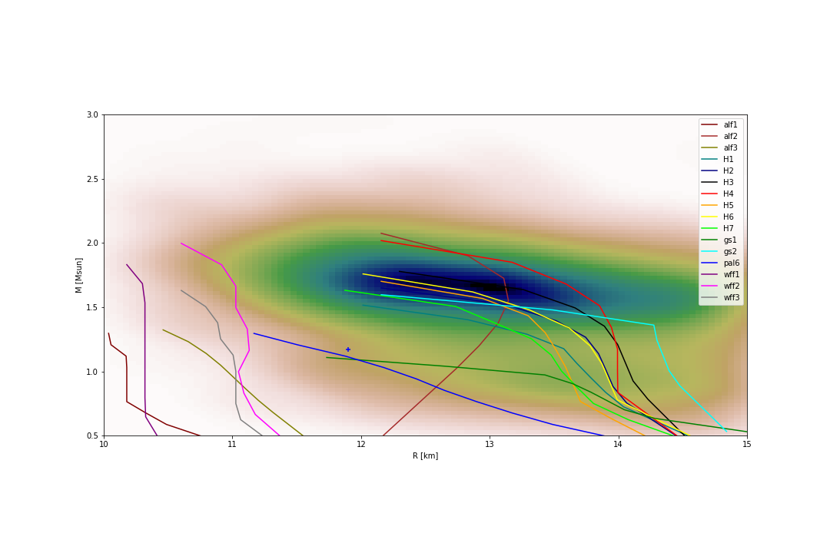similarity to identify the components that cause it to be the more accurate EoS.

After plotting the EoS with the Kernel Densities, the Bayesian Evidence can be calculated. The Bayesian Evidence can be described with

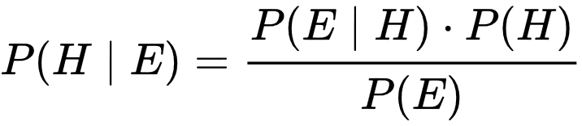

Equation Image courtesy of Wikipedia.com

Where P(E) is the probability of the evidence and P(H) is the probability of the hypothesis. Numerically, this equates to integrating the probability densities of the EoS with consideration of the star data. Adding the evidences for each of the Equations of State for both stars in the system provides the total evidence for the binary neutron star system. These total evidences can be used to then calculate the Bayes Factors (ratios of the evidences of the EoS to a chosen sample EoS). Finally, these Bayes Factors can be easily analyzed by inspection in order to determine which EoS has the best fit for the GW170817 data.

**Figure 2**: Kernel Density plot of Star 2 in GW170817 with EoS

**Results**

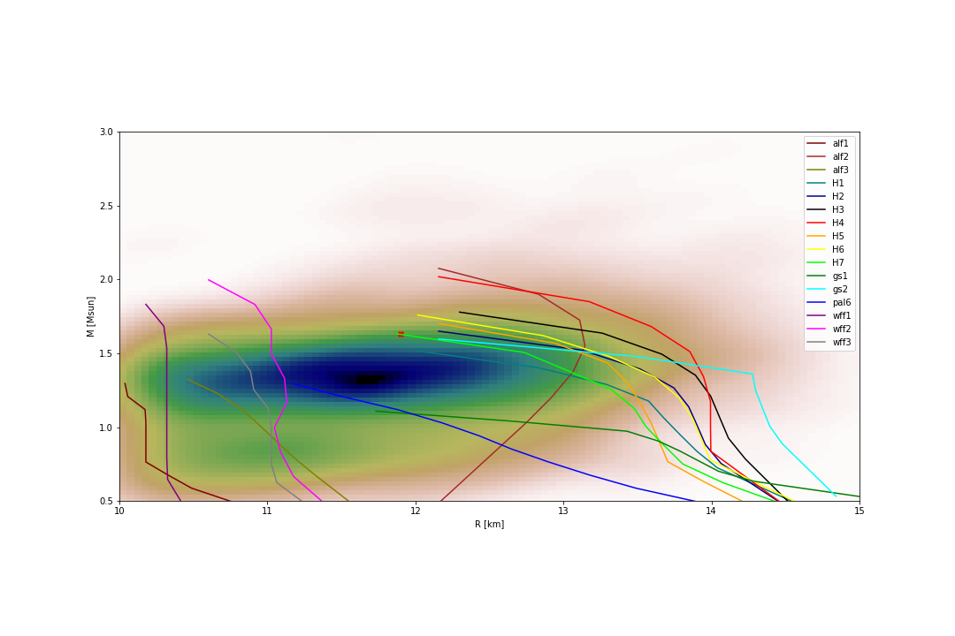Integrating the 15 EoS and plotting them with the Kernel Density can be seen in Figures 1 and 2. Inspecting the images individually suggests that equation pal6 is the most likely Equation of State to represent the data of Star 1 and H3 is the most likely equation to represent Star 2. Upon analysis of the joint evidences’ Bayes Factors, we obtain the following table:

**Table 1**: Bayes Factors for the EoS relative to the Equation H7

**Figure 1**: Kernel Density plot of Star 1 in GW170817 with EoS

|  |  |
| --- | --- |
| EoS in Numerator | Bayes Factor |
| alf1 | -9.32e-01 |
| alf2 | 2.48e-01 |
| alf3 | -6.57e-01 |
| H1 | -2.05e-01 |
| H2 | -8.02e-02 |
| H3 | -1.52e-02 |
| H4 | 6.03e-02 |
| H5 | 3.28e-02 |
| H6 | 7.30e-02 |
| gs1 | -1.31e+00 |
| gs2 | -2.67e-01 |
| pal6 | -5.98e-01 |
| wff1 | 1.62e-02 |
| wff2 | 2.82e-01 |
| wff3 | -1.94e-02 |

In the table, 60% of the Bayes Factors listed are negative, which suggests that the comparison equation H7 agrees most closely with the GW170817 data. Cases which have positive Bayes Factors imply that another model compared with the H7 fits the data better. The larger the absolute value of the Bayes factor indicates the degree of confidence assigned to the model preference. In many of the cases where the preferred model was H7 (the comparison model), it was preferred with strong confidence.

**Conclusions**

The results suggest that there is a preference towards EoS H7 when analyzed using the data from GW170817. This conclusion was drawn from the fact that it was a better fit than the majority of other models tested. It must be noted, however that some equations of state did show preference over H7. There were several possible factors that likely contributed to the extra inaccuracy. The first was the use of a standard gaussian distribution centered on the average Mass and Radius for the evidences instead of the more accurate Kernel Density. Though it would have been better to use this density, I was unable to manipulate it into a form readable by Python for calculating Bayesian Evidences. This means that the reference data was less well fit to the models than the true data would have been.

A second source of error could have arisen from the integration techniques used by the Python code. Most of the integration was done by the quad() function, a technique comparable to a trapezoidal Riemann sum used to approximate the area under the curve. This certainly would have resulted in a potentially substantial amount of error.

Outside of the tools used for this study, error also came from the values themselves, in particular the masses of the stars in the binary system. The masses listed by LIGO were given as a range, and this range differed slightly depending on if it was calculated with a high-spin or low-spin. When choosing the sample mass, I averaged the larger of the two ranges for each star to make sure not to exclude any values. This average did not take into account any potential preference for the mass to be either greater or less than the unweighted average of the range. In fact, when looking at the positioning of the point of highest density on the Kernel Density graphs, it is easy to see that these points fall within the range listed, however the average calculated actually lies outside this high density region.

This project presented a number of challenges. The first challenge was finding the correct masses to use. Initially, I used the joint masses of the stars in the calculations. It turned out that it was better to consider each of the stars individually (using the separate masses) and then sum the results together. Another challenge was in incorporating the Kernel Density. While the standard Gaussian easily integrated with the built in Python functions, the Kernel Density was not as easy. Had I been able to use the Kernel Density with the quad() function, the evidence values would have been more reliable and accurate. This is because the true probability density is not as evenly spaced as the standard Gaussian implies.

References

Special thank you to Phil Landry for helping me in troubleshooting the code and providing strategy suggestions for approaching the science and code

GW170817 - THE FIRST OBSERVATION OF GRAVITATIONAL-WAVES FROM A

BINARY NEUTRON STAR INSPIRAL. Retrieved from https://www.ligo.org/detections/GW170817.php

Abbott et al, B. P. GW170817: Observation of Gravitational Waves from a Binary Neutron Star

Inspiral. Retrieved from American Physical Society

StackExchange Posts for Python Assistance. Retrieved from https://stackexchange.com

University of Arizona, X. A. G. Neutron Stars. Retrieved from

http://xtreme.as.arizona.edu/NeutronStars/

GW170817: Measurements of neutron star radii and equation of state. Retrieved from

https://dcc.ligo.org/LIGO-P1800115/public